Technical Documentation

Contents Page

1. **Introduction pg. 2**
2. **Aim of the Program – pg. 2**
3. **How does the program work? – pg. 2**
4. **List of Features – pgs. 3 to 6**
5. **Block Header with Comments – pgs. 7 to 11**
6. **Data Declaration – pg. 12**
7. **Evaluation – pgs. 13 to pgs. 16**

**M4 - Create technical documentation for the support and maintenance of a computer program**

**Introduction**

In this report, I will create a technical documentation explaining my program.

**‘The Plumbing’ service**

**Goal of the application**

This system was designed to erase errors for the plumbing service. It offers many services for the user to be comfortable with the new system. The problem that the plumber faced is that there are often errors in his calculations; which have resulted in him carrying out work for very small profit, and sometimes losing work because his estimate was too high. The program was made before to erase the errors, but the new task was to make it an object oriented way.

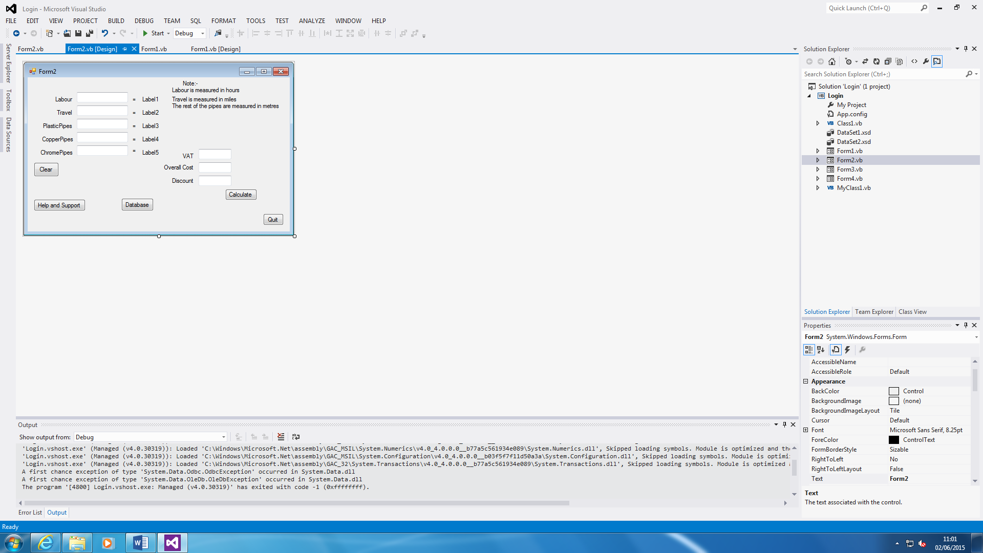

**How does the program work?**

1. Open the program up. Wherever it is located, you need to find it and open it up.
2. Enter Username and Password
3. Enter all calculations
4. Click the ‘Calculate’ button once finished
5. Reset by pressing ‘Clear’ button
6. Use Database if necessary.
7. If any support needed, click ‘Help and Support’ button for any assistance
8. Exit the application by clicking ‘Quit’ button

**List of Features**

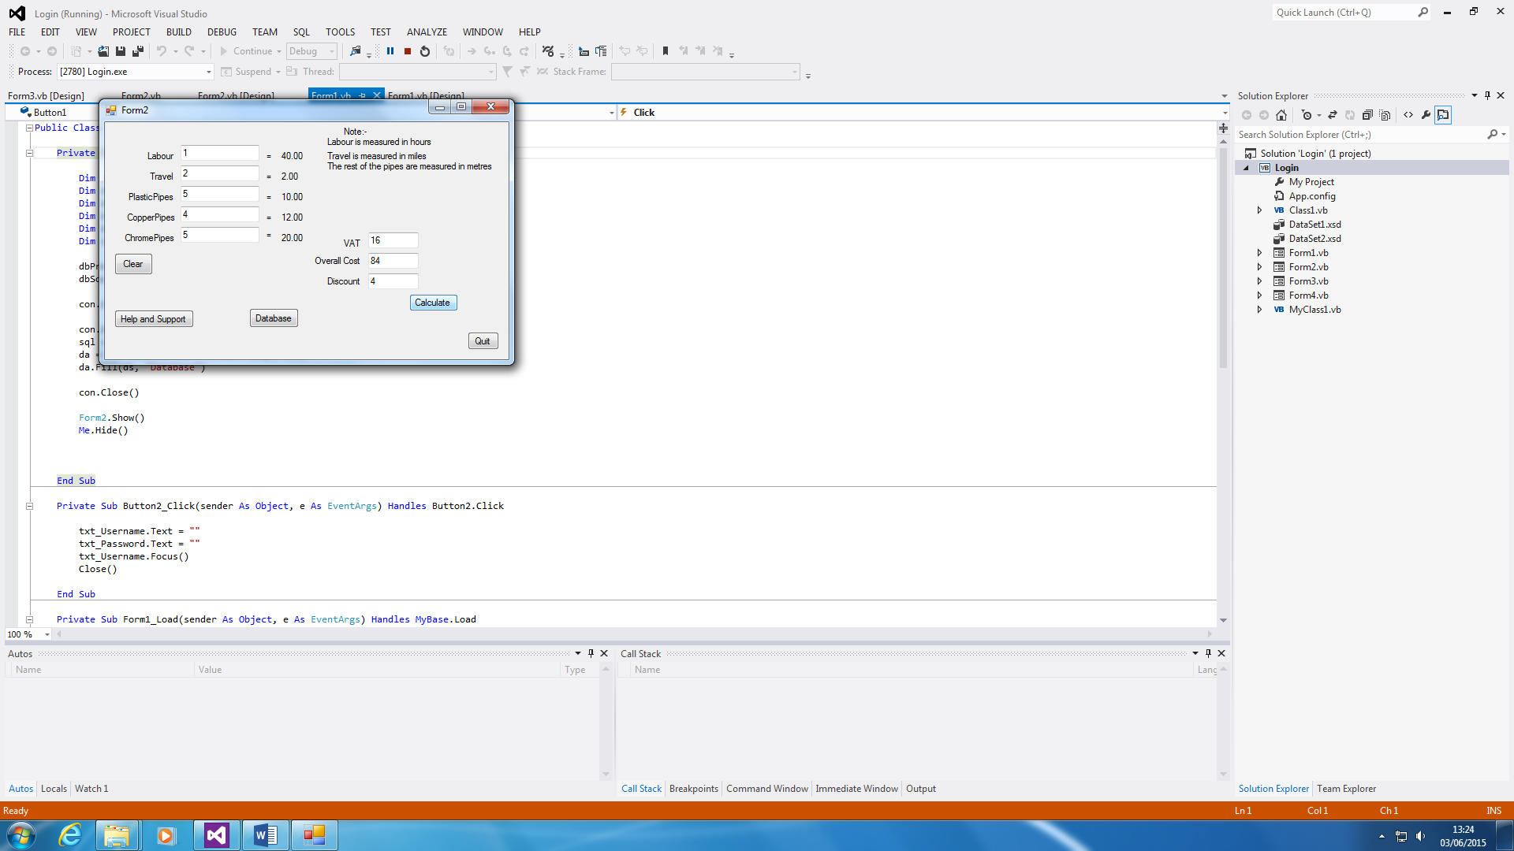**Clearing**

Clearing button shows us that you can restart the whole calculations if there is any errors. The code below shows that all of them are cleared.



**Database**

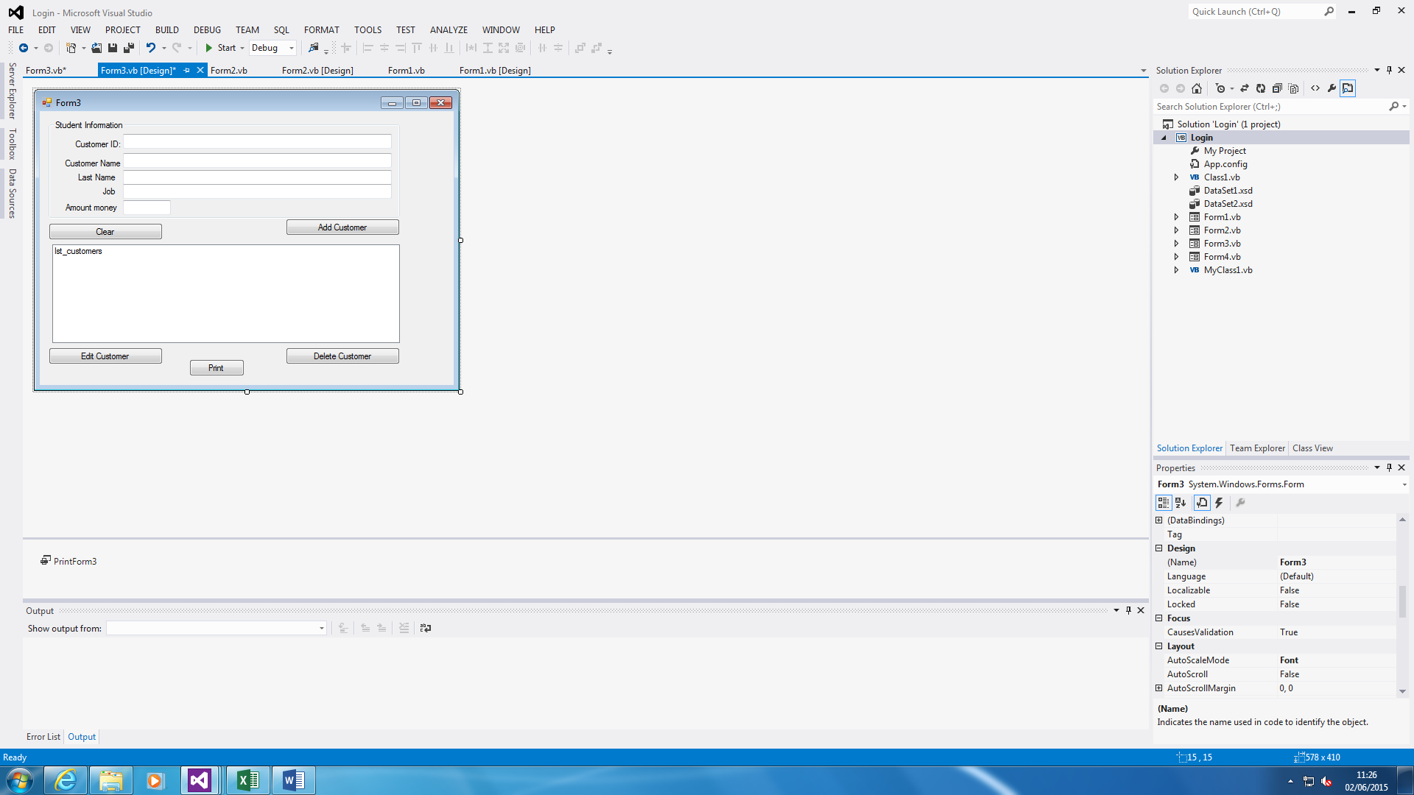

This database is different to the previous one we made. All you have to do for this one is fill in the missing boxes. You can add, edit and delete the customer name too. To keep in track with what you have submitted within the form, you can print it out too.

**Calculate**



This is the part where the user needs to fill in for the calculations to be complete.

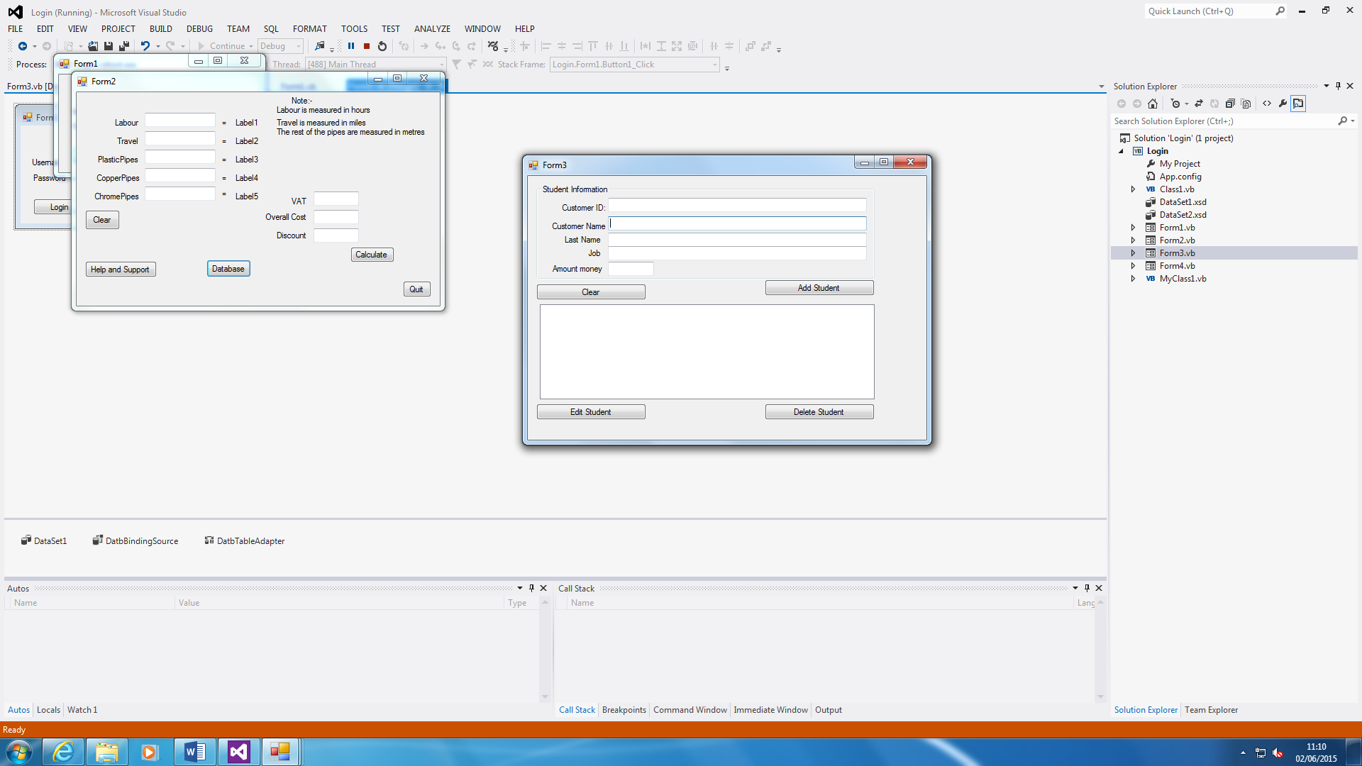**Summary**

This is the summary of the customer ID, customer Name, Last Name and Job with Amount Money. It shows a database summary of the whole database.

**Help and Support**



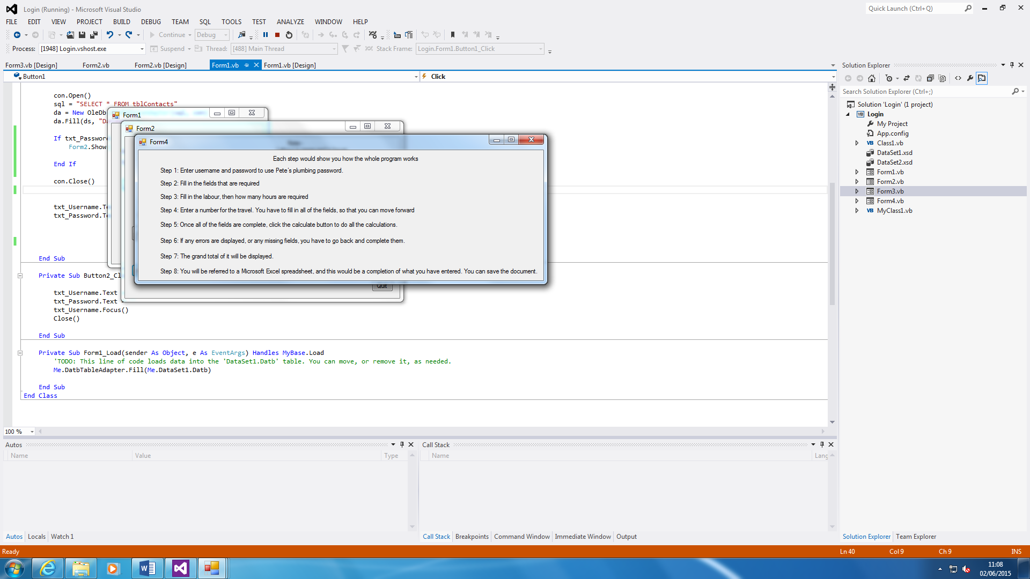

Help and Support button is easy. If the user has any problems with it, he/she can use the systematic guide of how the program is run. As you can see, it shows how it works. For example, if I did not know how to clear the whole Textboxes, I will use the Help and Support button to help me out. All you do is press the button and another sheet shows the steps.

The code is there to show that how Form2 is linked with the Help_and_Support Form. This is what you type to link it together once the button is clicked.

**Login Screen**

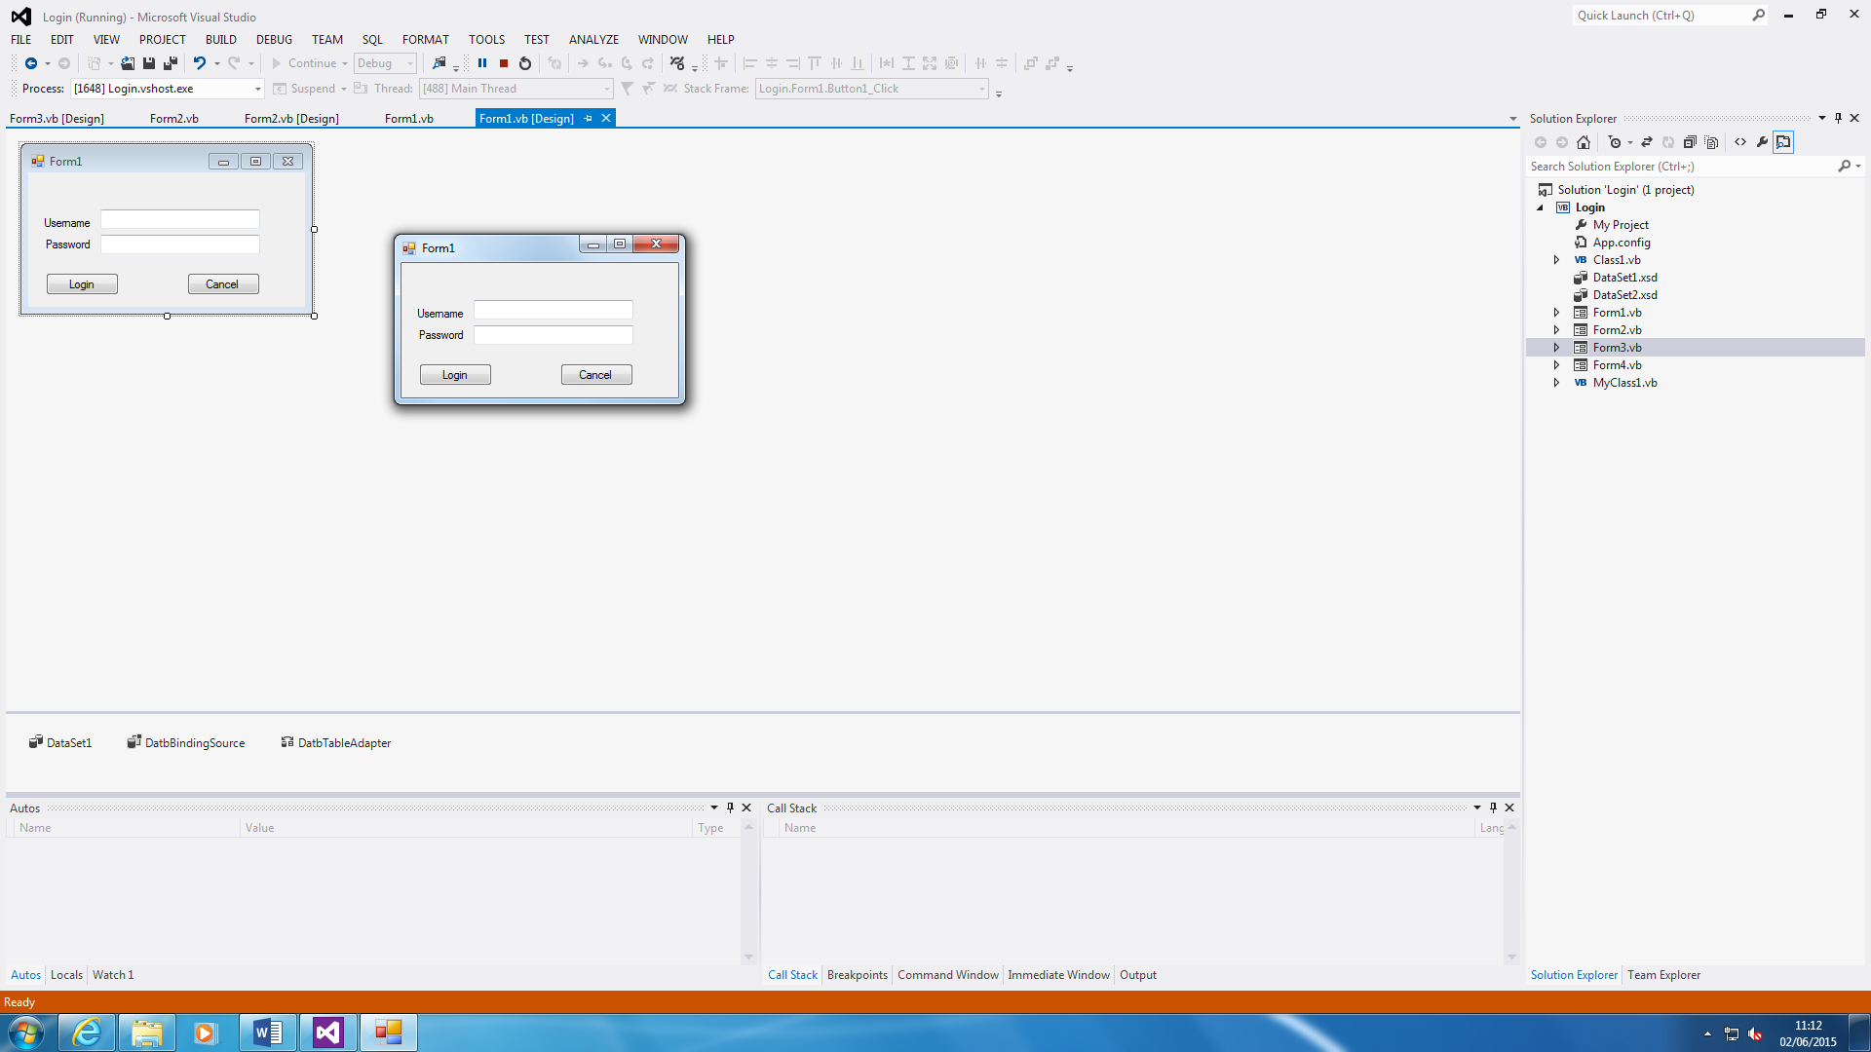

This is the login screen. It is different to the one that was previous on the system. It is linked to the database. If incorrect, it will be linked to the database and check if it is correct on there. If not, it will not allow you to enter to the Main Form. The cancel button clears both Textboxes and quits the application.

**Block Header with Comments**

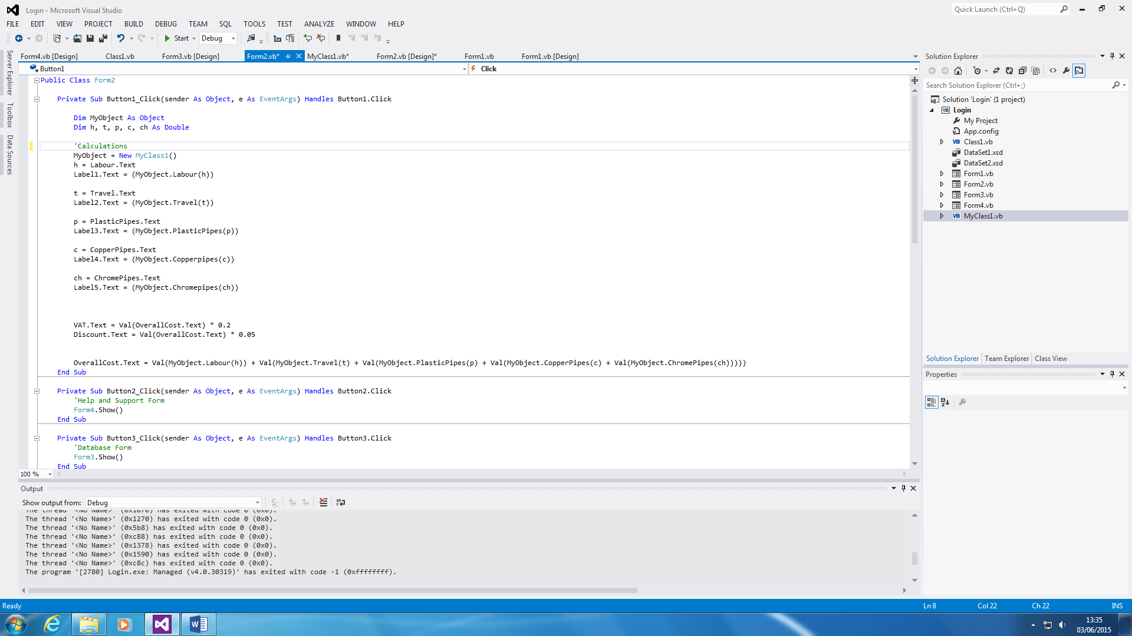**Main Form**

Figure 1.1

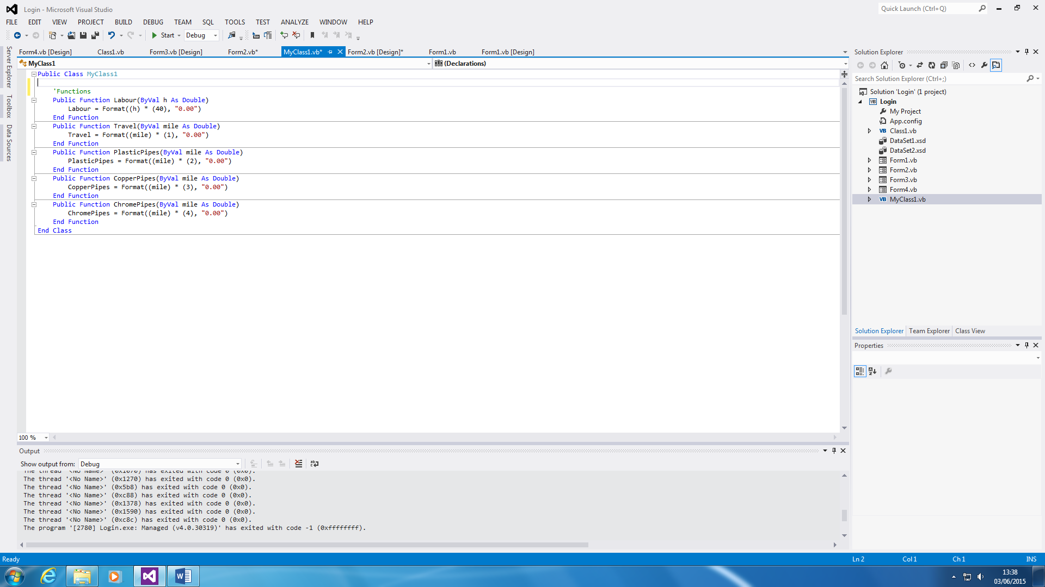

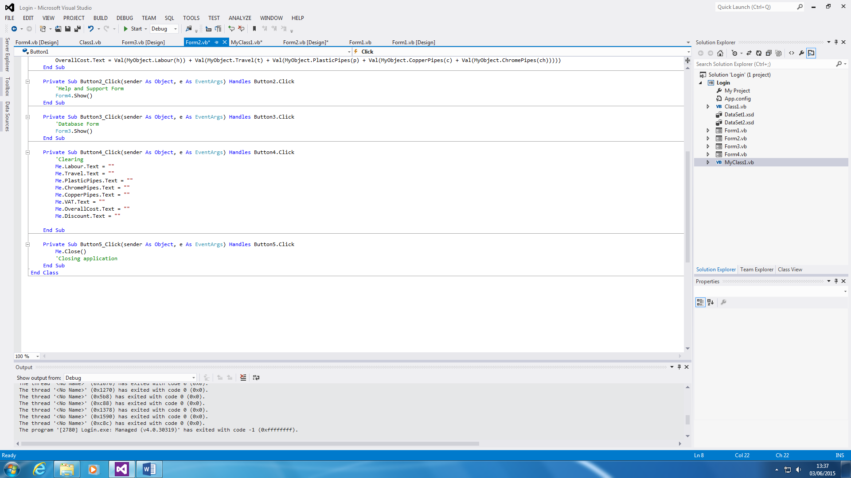

This is the main form shown on the codes. Referring the Figure 1.1, the first two screenshots are linked with each other by both of them completing the calculations on the Main Form. The first screenshot is linked to the second screenshot (class) by ‘MyObject = MyNewClasss1’. The calculations is being done in the Class Form by linking the Main Form code with the class by using the yellow highlighted for it to work.

Figure 1.2 is codes that are on the Main Form. The first code is linking the code to the database. The second code is clearing with the last one quitting the application.

Figure 1.2

**Login Screen**

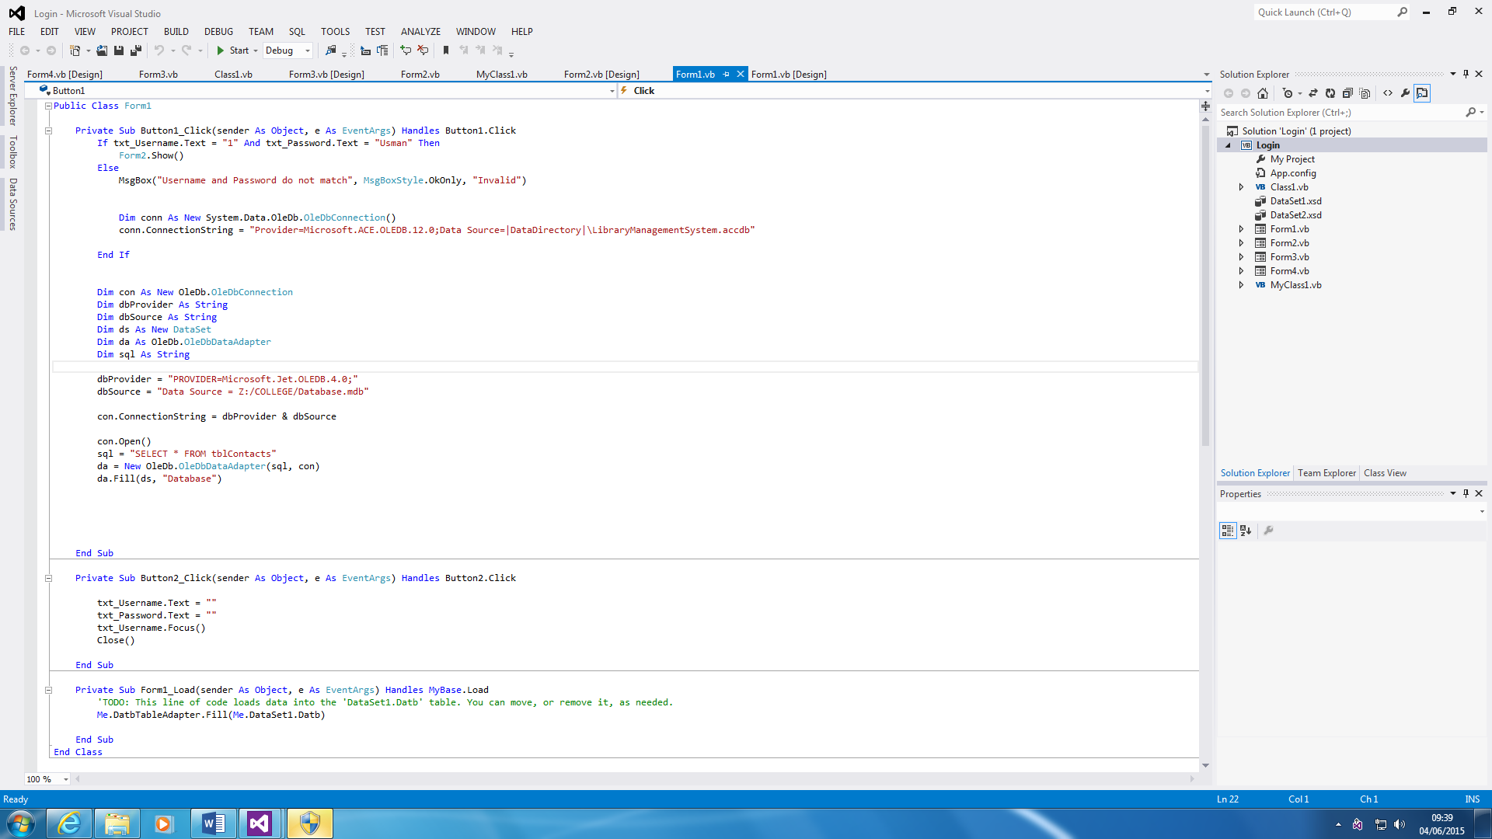

This is the code for the Login Screen. It links the login with the database.

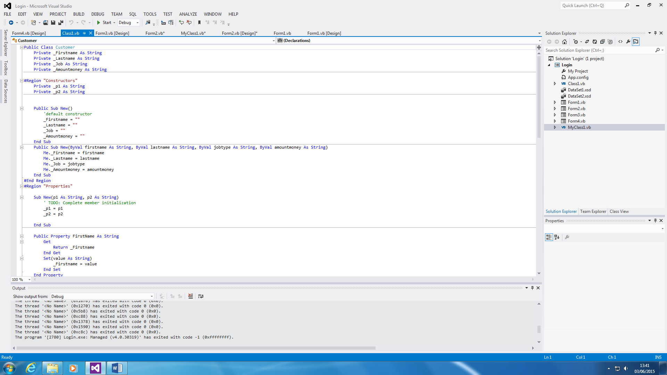**Database**

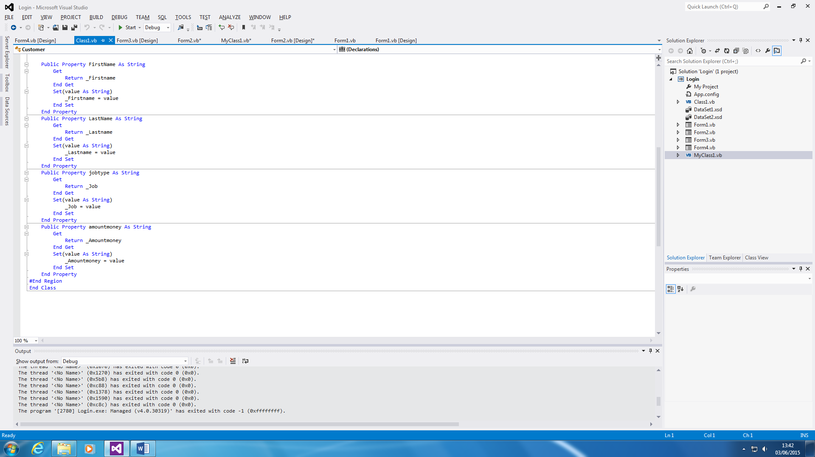

This is the Class code for the Database. This is all separated to construct the code for the Database code. The first section of the code uses it to tell what is what. It organises it. The second part tells is what to do.

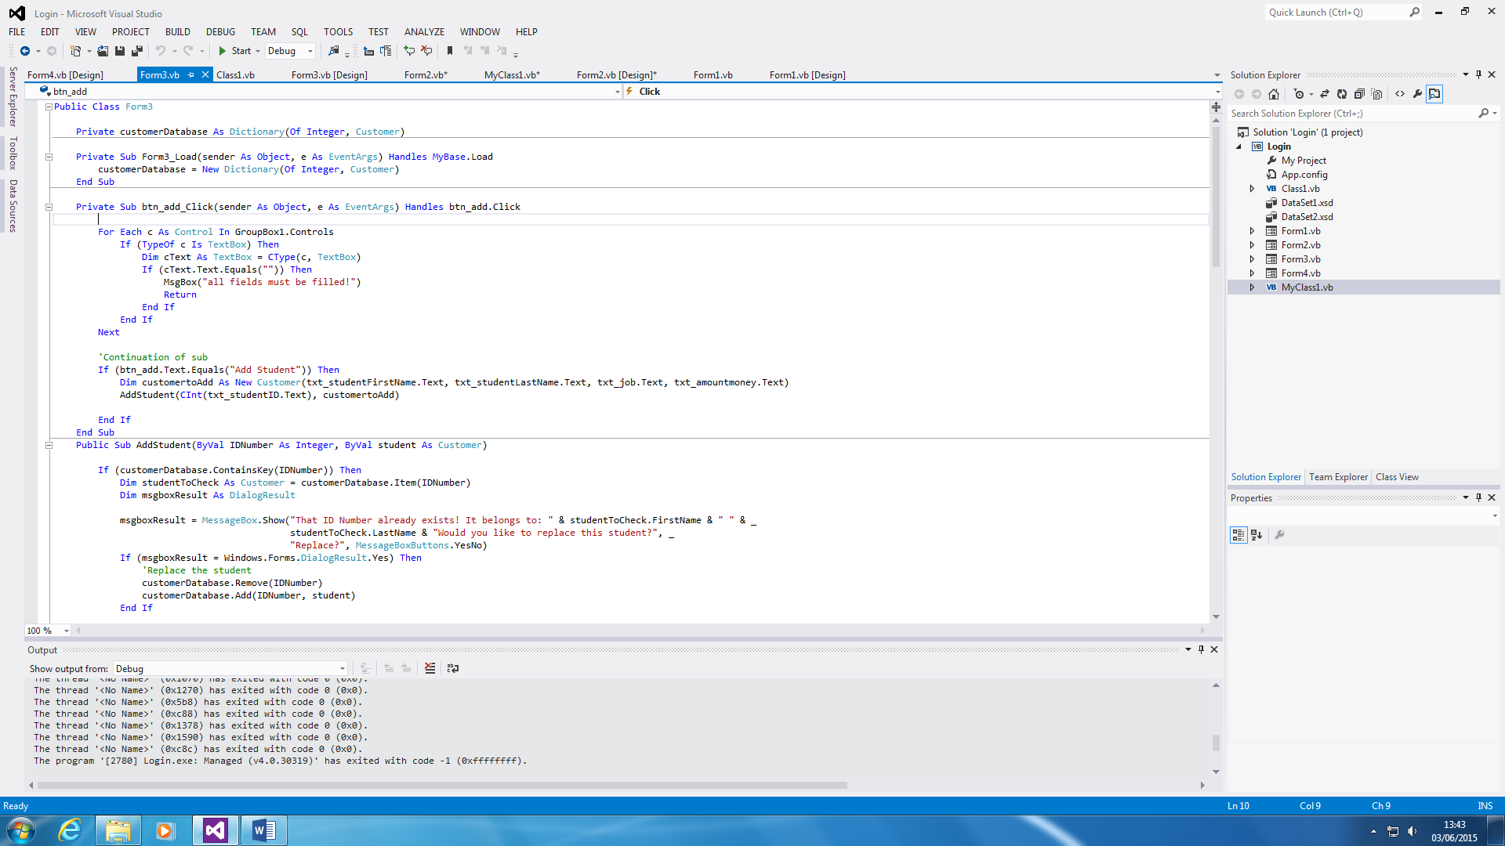

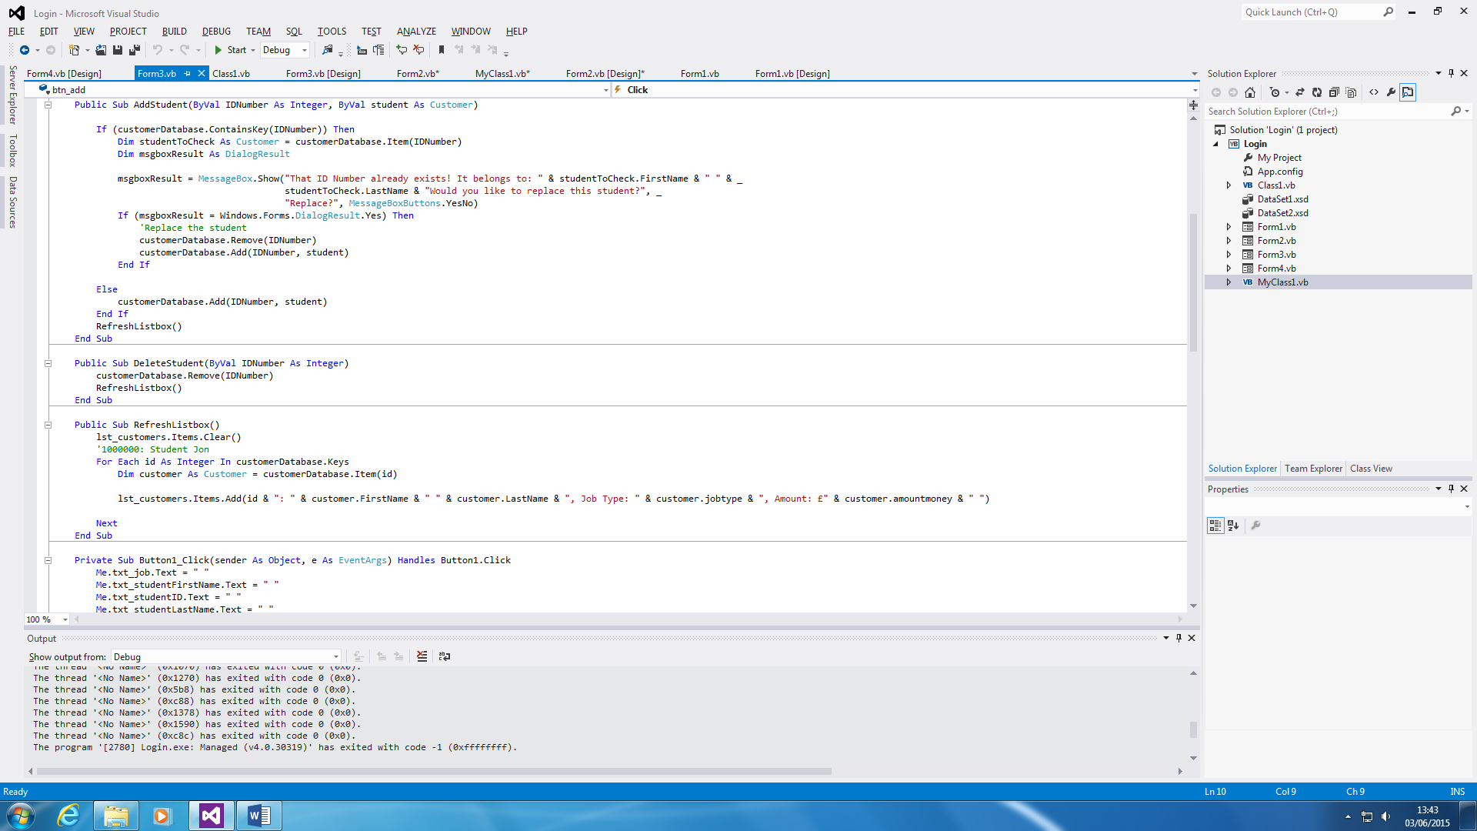

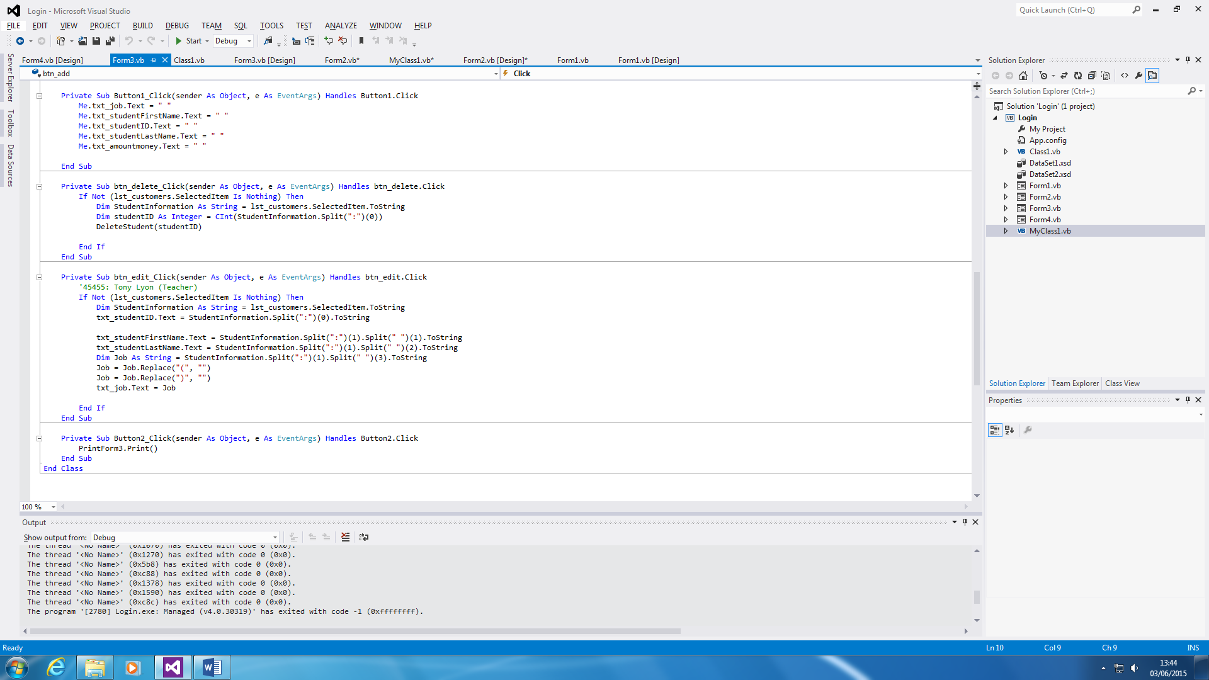

This is the database code. It is the breakdown of the database. The first IF statement is the adding the customer. The second is removing a customer. The third is for the List Box and forth is clearing the whole section.

**Data Declaration**

The purpose of this is for the H, T, P, C and CH to be represented as the calculations. The calculations is being linked with the class. Therefore, it being linked can enable the calculations on the Main Form to be complete. String is used so that the user can type in anything with 2 billion Unicode characters to choose from.

The Class Form is shown below.



The functions is used to declare what is used within the calculations. All of them use Decimal as numbers is inserted within the Textboxes.

**D2 – Evaluate an object oriented application**

**Introduction**

In this report, I will be evaluating whether I have met the requirements. I will say what improvements I will need to make for my event driven application.

**Requirements**

These are the requirements that were set at the beginning of the project. We have followed this scenario, shown below, in order for the design that I have made to be make. To summarise, the user has a manual system and in order to improve it, he needs a program that does it for him. The code of the job is highlighted in black.

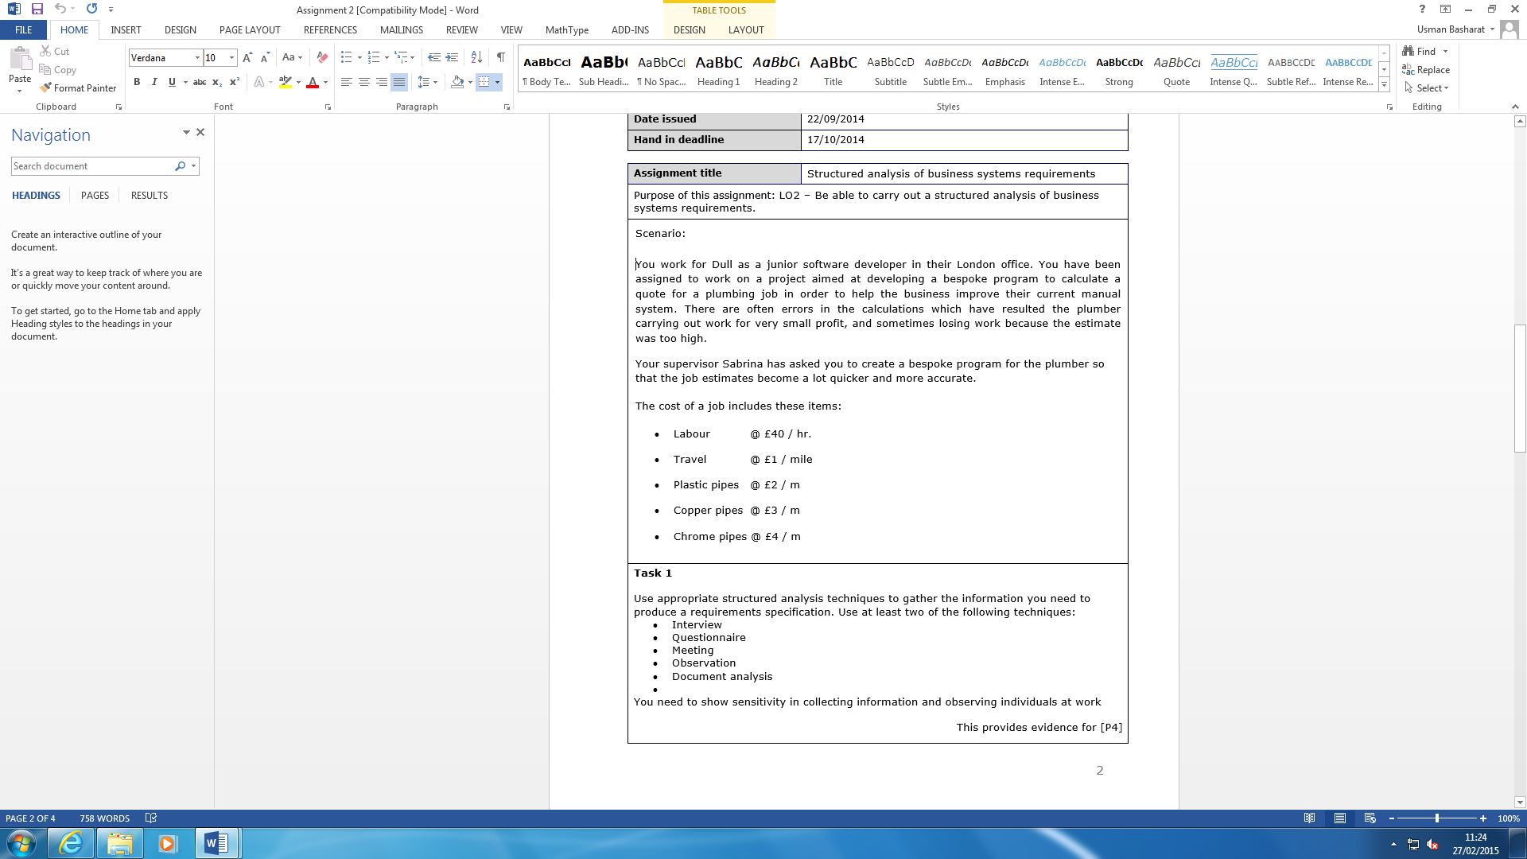

Figure 1.1

We have changed the way it looked previously. Before, it was an Event-Driven Application, but this time; it is changed to Object Oriented Application. The requirements were that the plumber would make his job much quicker and accurate. These requirements have been met. The interface of the application has changed due to the switch of programming.

The way it works is by the plumber entering the quantity of each of the job shown above.

The total would be shown below.



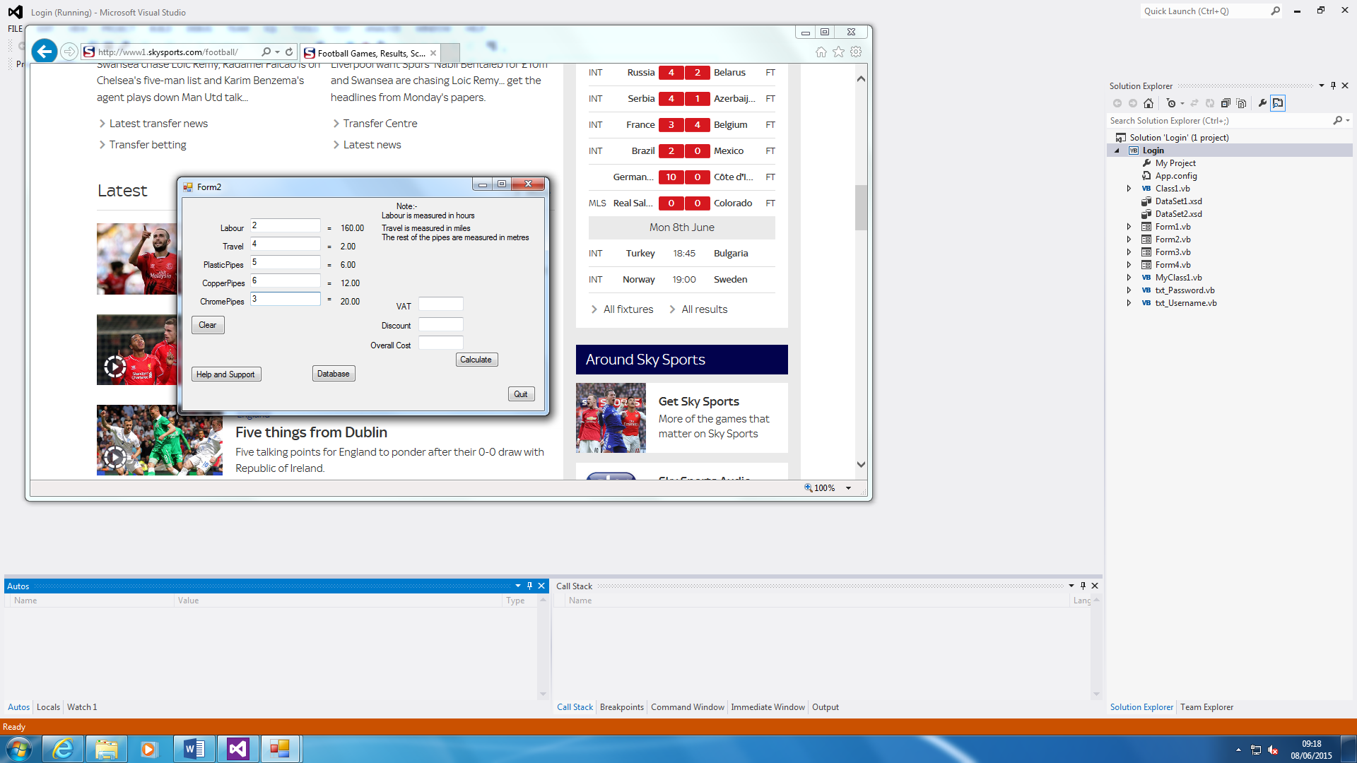**Input Process Output**

These are each of the stages which are the Input, Process and Output. The first process is to type in the quantities within the boxes. The process is to click the ‘calculate’ button. The output is the three boxes at the bottom.

**Design**

**Login Screen**

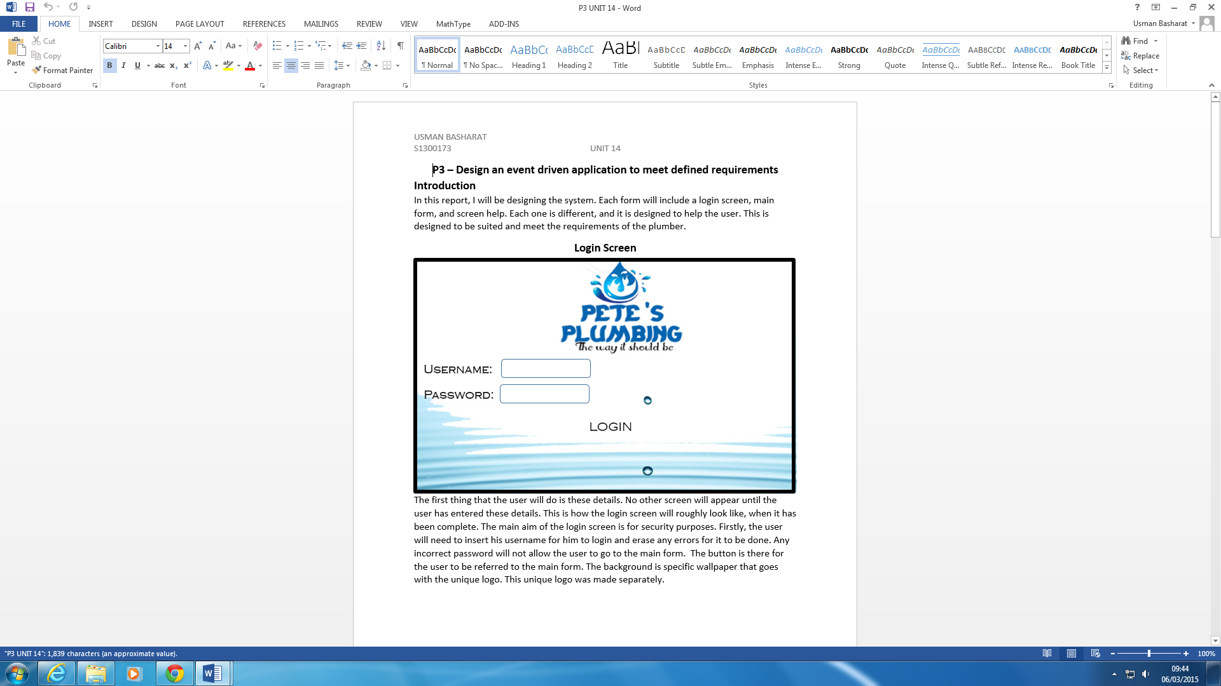

There is no difference between the two Login Forms. The design was made before I made the program. All I added is the ‘Cancel’ button which removes what is added within the Boxes and quits the application too. I did not add the Pete’s plumbing logo as I did not feel necessary for it.

**Main Form**

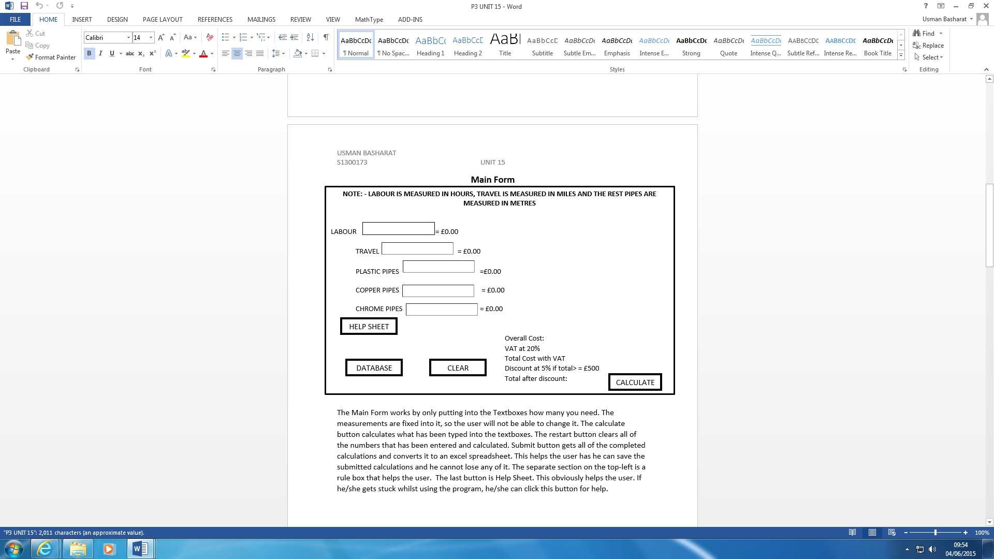

The difference between the two is similar. I put in a little message for the users to know what each job is measured in. This will help the user know what to type in and calculate it accurately.